**DAILY ONLINE ACTIVITIES SUMMARY**

|  |  |  |  |  |  |  |  |  |
| --- | --- | --- | --- | --- | --- | --- | --- | --- |
| **Date:** | **08/07/2020** | | | | | **Name:** | **Shailashree** | |
| **Sem & Sec** | **IV sem & B section** | | | | | **USN:** | **4AL18CS077** | |
| **Online Test Summary** | | | | | | | | |
| **Subject** | | **Design and Analysis of Algorithm** | | | | | | |
| **Max. Marks** | | **30** | | **Score** | | | **-** | |
| **Certification Course Summary** | | | | | | | | |
| **Course** | **Predictive modeling and analysis** | | | | | | | |
| **Certificate Provider** | | | **Greatlearning academy** | | **Duration** | | | **2.5hours** |
| **Coding Challenges** | | | | | | | | |
| **Problem Statement1:** Given two strings a and b consisting of lowercase characters. The task is to check whether two given strings are anagram of each other or not. An anagram of a string is another string that contains same characters, only the order of characters can be different. | | | | | | | | |
| **Status: Executed** | | | | | | | | |
| **Uploaded the report in Github** | | | | | **YES** | | | |
| **If yes Repository name** | | | | | **Online coding** | | | |
| **Uploaded the report in slack** | | | | | **YES** | | | |

Online Test Summary: 18CS42 test was scheduled for 10:07 am t0 11:00 am And the test scores not yet received .The portion for the IA was 1sh module there were 3 questions and the time assigned was 40 minutes the questions were written type. We have to write ans in A4 sheet and upload ans sheet as pdf document in google classroom in folder named as DAA_IA-1.

Online Certification Course Summary: Today I started new course that Predictive modeling and analysis in Great Learning. In today’s session I have learnt about Best fit line and Multiple Regression.

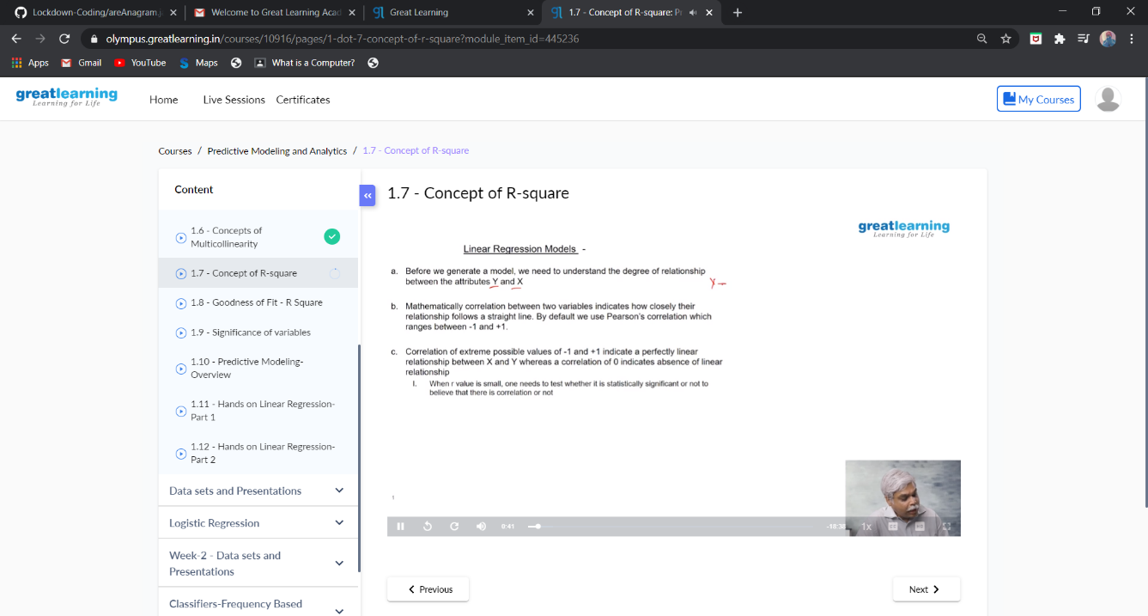

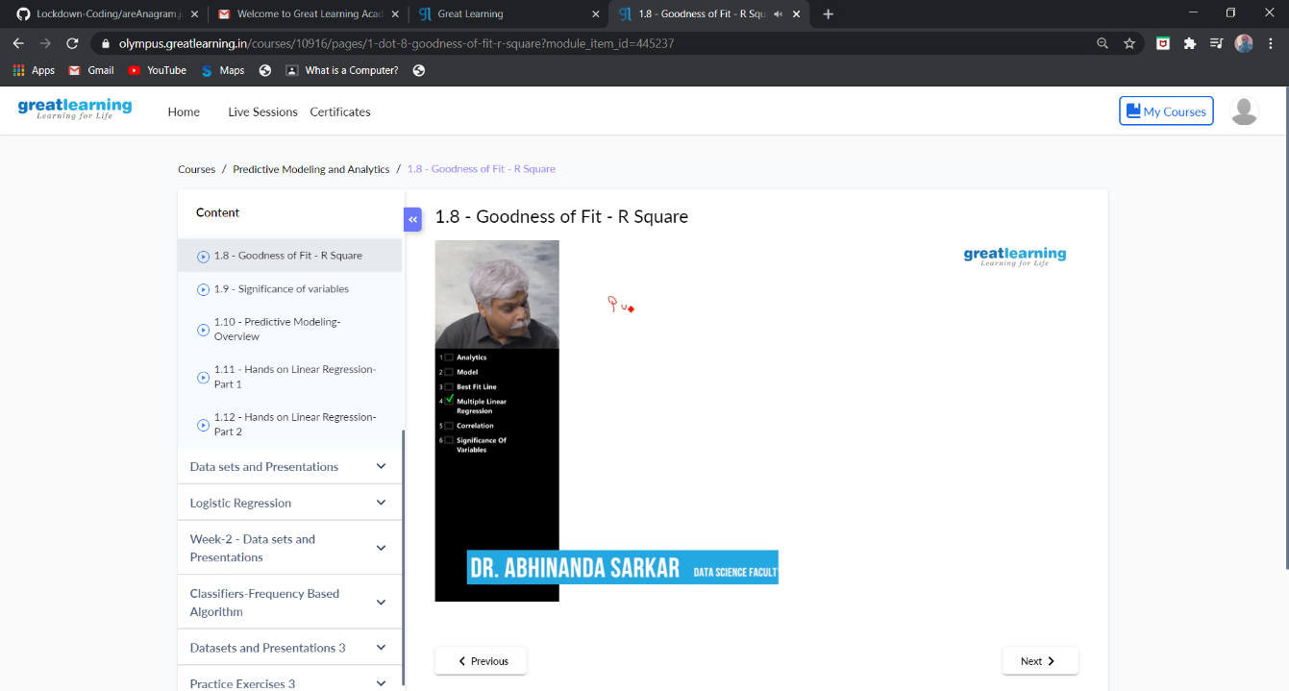

These are the snap shots of today’s sessions.

Online Coding Summary: **Today I had received one program from prof. Shilpa CSE Dept. The program is mentioned above in the coding challenges(pg.01). I have also uploaded it to my GitHub repository.**

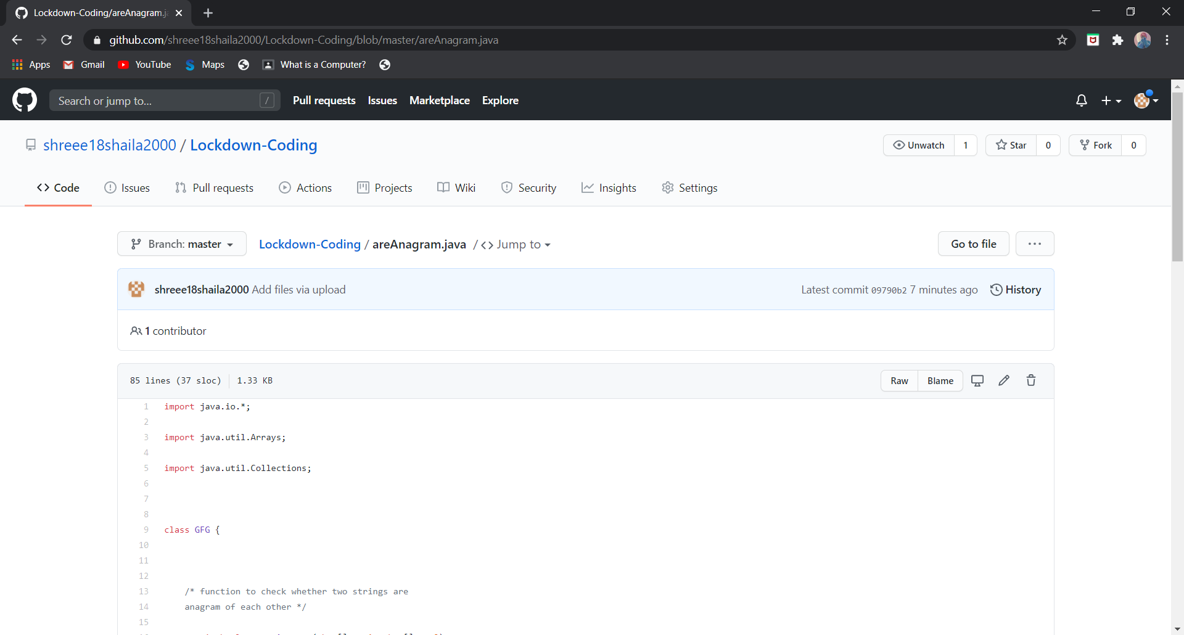

**This is the snap shot of my GitHub repository** where I have uploaded the code. File name is areAnagram.java.

Online Training: No training classes are conducted.